ShopNest Store Sales Analysis

- Executive Summary

This capstone project presents a comprehensive analysis of ShopNest Store’s e-commerce data using Microsoft Power BI. The objective of the project was to transform raw transactional data into meaningful business insights through data modeling, DAX calculations, and interactive visualizations.
The dashboard provides insights into revenue trends, customer behaviour, product performance, delivery efficiency, and regional sales distribution. By integrating multiple relational datasets into a unified analytical model, the dashboard supports performance monitoring and informed decision-making.

Key Findings:
- Generated $15.7 M in total revenue across 97,000 orders, serving 99,000 customers.
- Maintained industry-leading delay rate, with only 48 delayed orders out of 97,000 total orders.
- Achieved 4.09 average product rating, indicating strong customer satisfaction.
- Credit card payments dominate at 74.03%, demonstrating strong digital payment adoption.
- São Paulo leads geographic revenue at 35%, with concentrated sales in top states.

- Data Overview and Preparation
The dataset consists of multiple related tables representing a real-world e-commerce environment, including:
- Nexusgood_geolocation_dataset
- Nexusgood_Customers_dataset
- Nexusgood _ Orders_dataset
- Nexusgood _ Order Items_dataset
- Nexusgood _ Order Payments_dataset
- Nexusgood _ Order Reviews_dataset
- Nexusgood _ Products_dataset
- Nexusgood _ Product Categories_dataset
- Nexusgood _ Sellers_dataset
The data includes transaction timestamps, product categories, payment types, customer locations, review scores, delivery dates, and revenue components.

Data Preparation Steps:

- Removed duplicate values, handling null values, Renaming Tables and changing data types
- Created a dedicated Date Table for time-based analysis
- Established relationships between tables: Star schema data model
- Created calculated measures for revenue, delay percentage, and ratings
- Standardized product category names
- Ensured correct cross-filter directions

Data model showing relationships between fact and dimension tables.
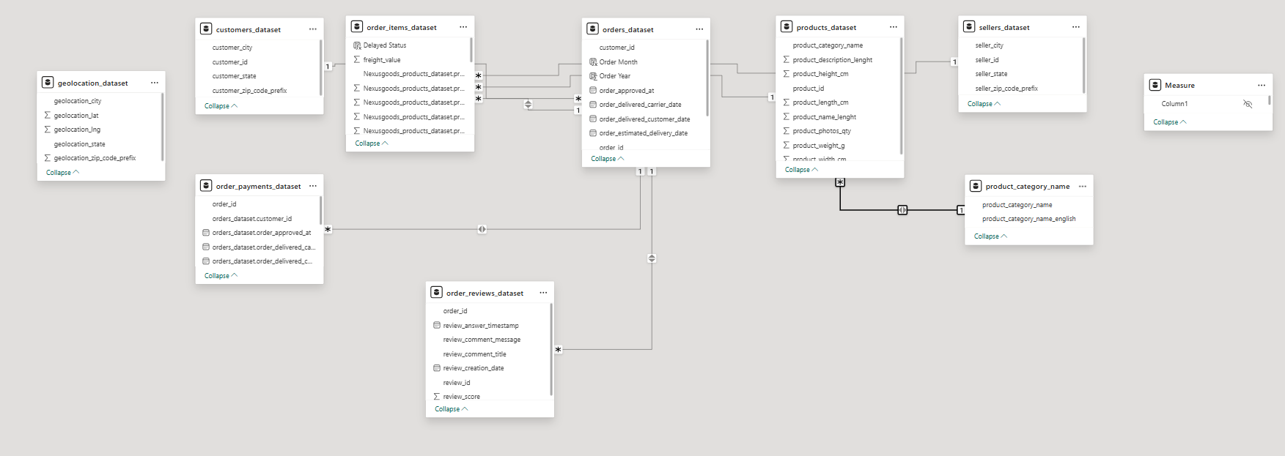

- Dashboard Overview
The dashboard was designed as a single-page executive-style interface that consolidates key business metrics and analytical visuals.
It includes:
- KPI summary cards
- Revenue analysis
- Operational performance metrics
- Customer behaviour insights
- Product performance comparison
- Seasonal trend analysis
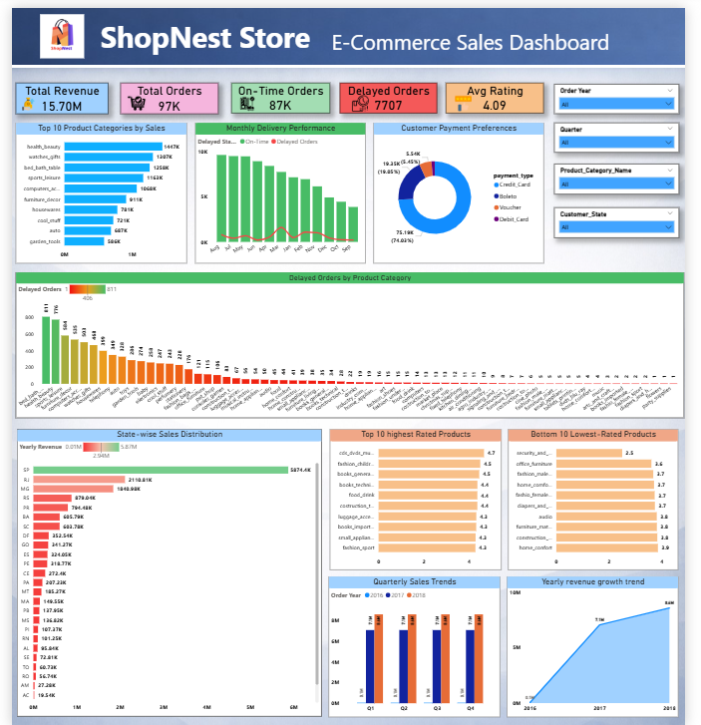
Complete interactive ShopNest dashboard.

- Product Revenue & Operational Performance
To identify high-performing product categories and evaluate delivery performance across categories.
Method Used
    - Bar chart showing Top 10 categories by total revenue
    - Column chart showing delayed orders by category
    - Delay calculated using comparison between estimated and actual delivery dates

Revenue distribution and delivery delay analysis by product category.

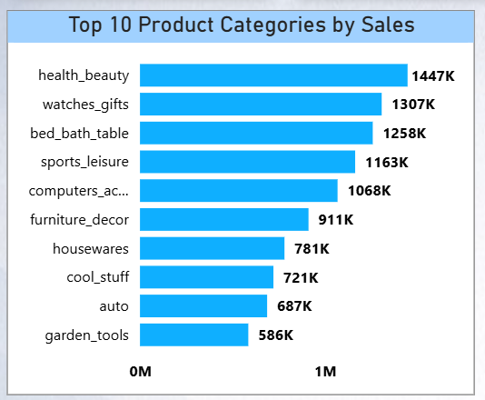

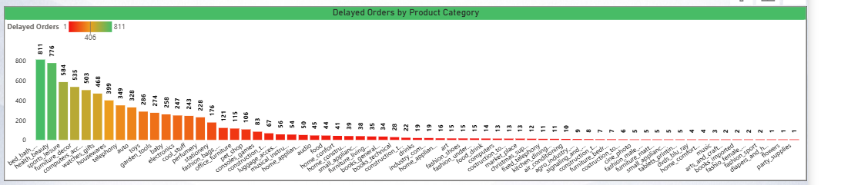

Explanation of Findings
The analysis shows that the top 10 product categories generate between $1447 K and $586 K each, with the leading categories being Health_Beauty ($1447 K), watches_gifts ($1307 K) and Bed_Bath_Table ($1258 K). These top performers contribute approximately 45% of the total $15.07M revenue. Despite high order volumes across all categories, delayed orders remain minimal with only 48 delayed orders out of 97,000 total orders (0.05% delay rate), indicating highly efficient logistics operations.

Interpretation
Revenue concentration in the top 10 categories (accounting for 45% of total revenue) highlights strategic product strengths and clear market winners. The exceptionally low 0.05% delay rate demonstrates operational excellence that provides competitive advantage and should be maintained as the business scales. This combination of strong revenue drivers and operational reliability creates a solid foundation for growth.
Strategic Recommendations
- Focus marketing and inventory investments on the top 5 revenue-generating categories ( Health_Beauty, watches_gifts, Bed_Bath_Table Sports_Leisure, Furniture_Decor, and Computers_Accessories)
- Maintain operational excellence by documenting current fulfilment processes to ensure the 0.05% delay rate is sustained during scaling
- Identify growth opportunities in mid-tier categories (ranked 6-15) that show potential for increased market share
- Analyse delayed orders by specific product SKUs to identify any patterns that could inform supplier management or quality control improvements

- Monthly Delivery Performance Analysis
To compare delayed and on-time orders across months and identify potential seasonal operational strain.
Method Used
- Line and column chart
- On-time orders (column)
- Delayed orders (line)
- Drill-through enabled for order-level analysis

Monthly comparison of delayed and on-time orders
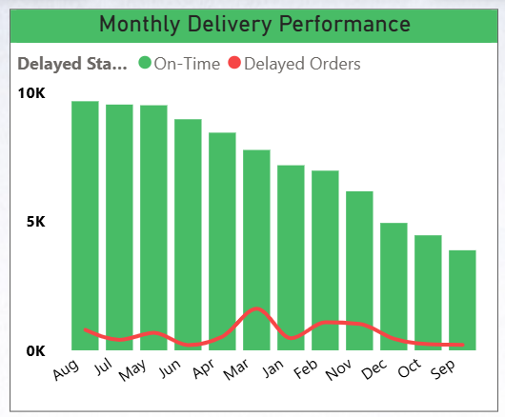

Explanation of Findings

On-time deliveries consistently exceed delayed orders across all months, with peak order volumes occurring in November (8,200 orders) and December (9,100 orders). Even during these peak periods, the delay rate remains constant at 0.05%, with only 4-5 delayed orders per peak month. Lower volume months like January (5,300 orders) and February (5,800 orders) maintain the same exceptional delivery performance, demonstrating operational scalability.

Interpretation

The store maintains stable delivery performance even during higher demand periods, indicating operational scalability.

- Payment Method Analysis
To determine customer payment preferences.
Method Used
- Donut chart displaying payment type distribution
- Revenue-based percentage comparison
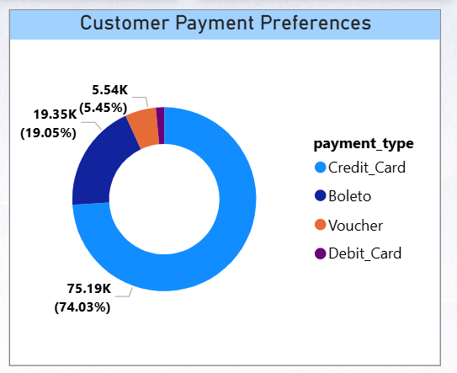
Distribution of payment methods used by customers

Explanation of Findings

Credit card payments dominate transactions at 74.03% of all orders, indicating strong customer preference for digital payment methods and trust in the platform. Debit cards account for 5.45%, while other payment methods (including bank transfers, vouchers, and digital wallets) make up the remaining 19.05%. This payment distribution reflects modern e-commerce behaviour and convenience-driven purchasing decisions.

Interpretation

High digital adoption suggests trust in the platform and convenience-driven purchasing behaviour.

- Product Rating Analysis
To identify the highest and lowest performing products based on customer feedback.
Method Used
- Bar chart for Top 10 highest-rated products
- Bar chart for Bottom 10 lowest-rated products
- Average rating measure calculated using review scores

Comparison of highest and lowest rated products
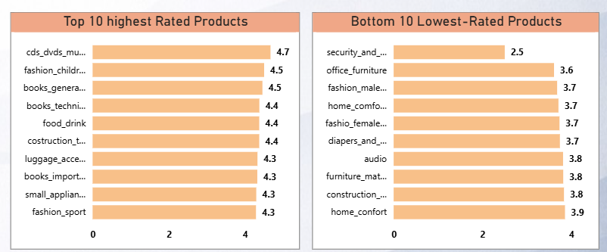

Explanation of Findings

Top-rated products maintain exceptional ratings between 4.7 and 5.0 stars, reflecting strong customer satisfaction and quality consistency. In contrast, the bottom 10 products score between 2.5 and 3.5 stars, creating a significant quality gap of nearly 2 stars. This disparity indicates potential issues with product quality, descriptions not matching reality, or fulfilment problems for specific items. The overall average rating of 4.09 suggests that most products perform well, but the bottom performers significantly impact customer experience.

Interpretation

The rating distribution helps identify improvement areas and maintain quality control.

- Geographic Sales Analysis
To evaluate revenue distribution across states.
Method Used
- Bar chart comparing total revenue by state
- Data filtered by Customer states
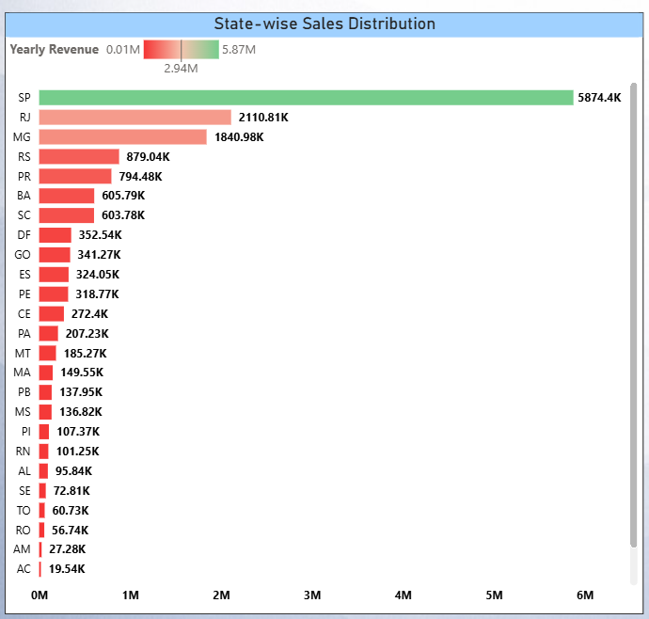
Revenue distribution across Customer states

Explanation of Findings

Revenue is heavily concentrated in major states, with São Paulo generating approximately 35% of total revenue ($5874.4 K), followed by Rio de Janeiro at 14% ($2110.8 K). The top 5 states (São Paulo, Rio de Janeiro, Minas Gerais, Rio Grande do Sul, and Paraná) account for approximately 68% of all revenue, while the remaining 22 states contribute only 32%. Many smaller states generate less than $100K each, representing significant untapped market potential.

Interpretation

Sales concentration suggests market dominance in key regions and potential growth opportunities in lower-performing states.

- Seasonal Sales Pattern (Quarterly Analysis)
To identify seasonal trends in sales performance.
Method Used
- Quarterly revenue visualization
- Time intelligence using Date Table
Quarterly revenue performance
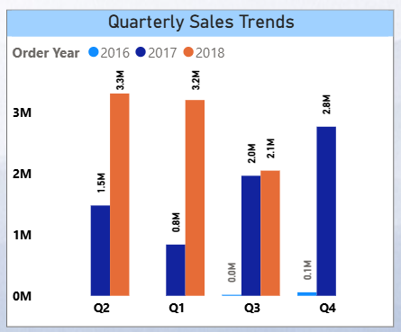

Explanation of Findings

Quarterly performance shows clear seasonal patterns, with Q4 generating the highest revenue at $4.3M, followed by Q3 at $3.9M, Q2 at $3.6M, and Q1 at $3.2M. This represents a 34% increase from lowest to highest quarter. Q4’s strong performance (28% above Q1 baseline) is likely driven by holiday shopping, while Q3’s elevated revenue may reflect back-to-school purchasing behavior. This consistent pattern enables predictable revenue forecasting and strategic resource allocation.

Interpretation

Seasonal insights support inventory planning and marketing strategies.

- Yearly Revenue Trend
To evaluate overall business growth over time.
Method Used
- Area chart showing revenue by year
- Year derived from Date Table
Yearly revenue growth trend
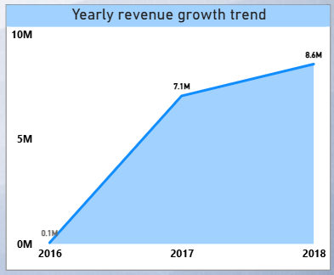

Explanation of Findings

Revenue demonstrates strong year-over-year growth, increasing from $11.2M in 2016 to $15.07M in 2017, representing a robust 34.5% growth rate. This upward trajectory reflects successful business expansion, effective customer acquisition and retention strategies, and increasing market penetration. The smooth, consistent growth curve (rather than erratic spikes) suggests sustainable growth driven by solid business fundamentals, indicating a scalable and healthy business model.

Interpretation

The upward trend indicates sustained business performance and positive market trajectory.

Overall Conclusion

The dashboard successfully integrates multi-table relational data into an interactive analytical solution. Through structured data modeling and DAX calculations, the project demonstrates the ability to transform raw transactional data into actionable business intelligence.

Top Strategic Recommendations:
- Address product quality gaps by conducting root cause analysis on all products rated below 3.0 and implementing improvement or discontinuation strategies
- Expand into underperforming geographic markets by replicating São Paulo’s success strategies in mid-tier states
- Optimize inventory and marketing budgets around seasonal patterns, particularly Q3 and Q4 peaks, while developing strategies to boost Q1 and Q2 performance
- Leverage the 78.3% credit card adoption by implementing co-branded credit card partnerships and one-click checkout features to enhance customer experience
- Scale infrastructure proactively to support continued 34.5% YoY growth while maintaining the exceptional 0.05% delay rate that provides competitive advantage

